**ASSIGNMENT** **FOR** **DIGITAL** **MARKETING**

1. Website by Blogger :

<https://dkdinakaran08.blogspot.com/2023/10/the-influence-of-digital-technology-in.html>

1. Facebook account:

<https://www.facebook.com/profile.php?id=61552660254492&mibextid=ZbWKwL>

Post link;

<https://fb.watch/nUHqaqZYF0/?mibextid=Nif5oz>

1. Create a post by using canva:

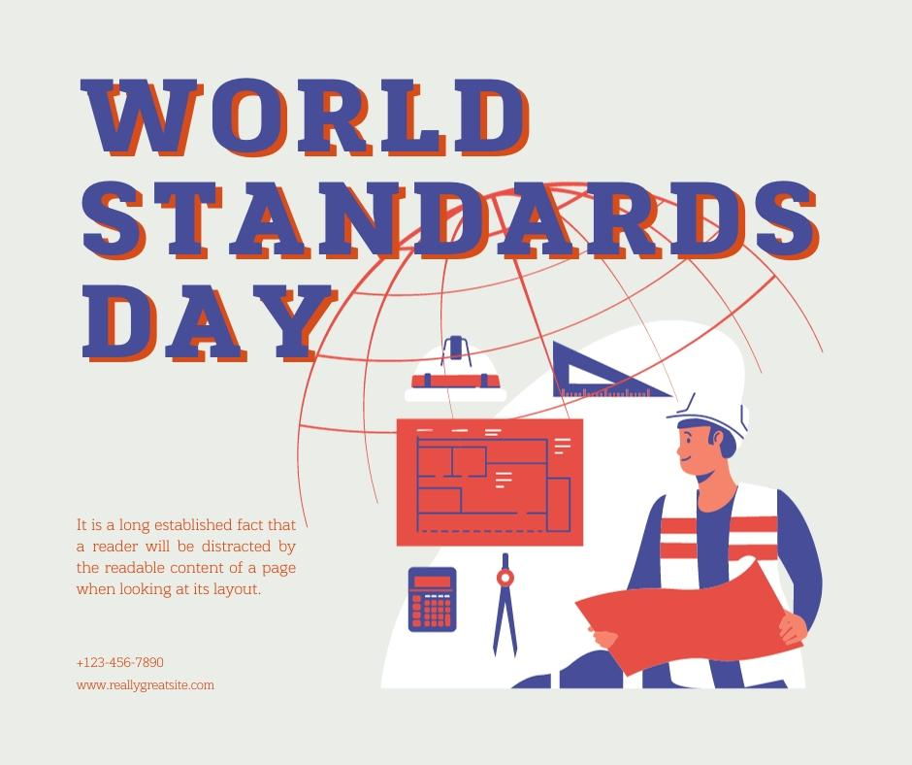

Social media link :

<https://www.instagram.com/p/Cy0T_7_i11N/?igshid=MzRlODBiNWFlZA==>

1. Create news letter by using canva:

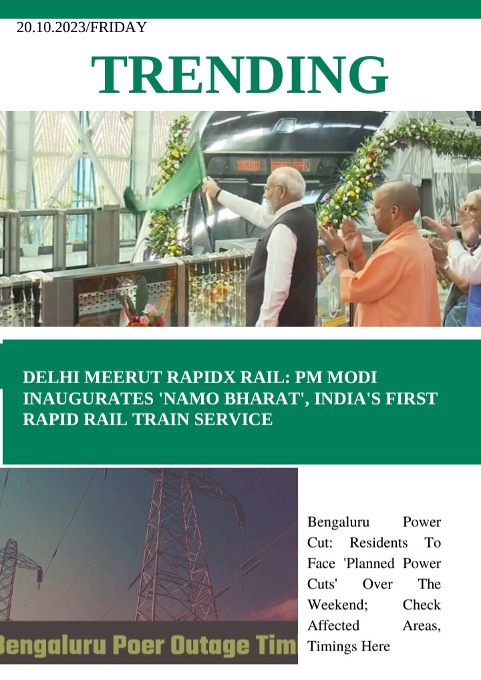

News letter link :

<https://www.instagram.com/p/Cy0U3YrCjoQ/?igshid=MzRlODBiNWFlZA==>